[View metadata, citation and similar papers at core.ac.uk *brought to you by* **CORE**](https://core.ac.uk/display/42920018?utm_source=pdf&utm_medium=banner&utm_campaign=pdf-decoration-v1)**

[*provided by* Universiti Teknologi Malaysia Institutional Repository](https://core.ac.uk/display/42920018?utm_source=pdf&utm_medium=banner&utm_campaign=pdf-decoration-v1)

Efficiency for Photovoltaic Inverter: A Technological Review

Zainal Salam

Centre of Electrical Energy Systems Faculty of Electrical Engineering Universiti Teknologi Malaysia

81310 Johor Bahru, Malaysia [zainals@fke.utm.my](mailto:zainals@fke.utm.my)

Azhan Ab. Rahman Faculty of Electrical Engineering Universiti Teknikal Malaysia Melaka

76100 Melaka, Malaysia

[azhanrahman@utem.edu.my](mailto:azhanrahman@utem.edu.my)

***Abstract*---It is recognized that a small percentage difference in the efficiency of a photovoltaic (PV) inverters causes a substantial variation in their cost. This is understandable because a PV inverter is expected to be in service for a good number of years (possibly as long as the PV modules themselves) and therefore the total energy yield that can be extracted using the inverter need to be considered in the initial investment calculation. However, there appears to be confusion on the real meaning of the term “inverter efficiency”. Unfortunately, there is no single documented reference available that can adequately describe the significant of these efficiencies and how are they related to each other. In most cases, the user only relies on the efficiency numbers stamped on the inverter nameplate as a guide during PV system dimensioning. Such approach may result in a non-optimized solution. This critical review paper is an attempt to clarify these confusions by gathering, organizing and analyzing the scattered information available around from various literatures. It is hoped that the information assembled in this paper can be a valuable guidelines for PV practitioners as well as researchers to kick start their research in this field.**

***Keywords---Inverter; MPPT; PV; efficiency; power converters*.**

1. INTRODUCTION

Despite their higher cost, electrical power generated from renewable energy (RE) sources are gaining considerable interest due to several factors: the abundance of the source itself, simple conversion technology, and environmentally friendly. Among the RE sources available, solar photovoltaic (PV) appears to be consistently growing at a very fast rate [1]. The price of PV modules has been falling down rapidly year-on-year for the past decade; as a result numerous PV power systems with various capacities (from several kW to MW range) are installed throughout the world. Furthermore, with the progress in the energy conversion technology, control and power electronics, the overall cost has been kept to be relatively affordable. In certain parts of the world (particularly in island and remote areas), PV electricity has reached the grid-parity point [15].

Assuming that the modules technology is known, the next major component that influences the design of a PV system is the inverter. For system designer/installer, the efficiency of the inverter is the most important factor in deciding the system configuration. This is due to the fact that for every 1% difference in the efficiency, the inverter cost varies approximately 10% [2]. Such large margin is understandable because the inverter is expected to be in service for a good number of years (possibly as long as the PV modules themselves) and consequently the total energy yields from its years of services need to be factored into the return investment (ROI) calculation. However, there appears to be confusion on the exact understanding of the term “PV inverter efficiency”, particularly among the non-academic personnel involved in the PV industries. In most cases, the user only relies on the efficiency numbers stamped on the inverter nameplate or datasheet (which normally indicates the peak efficiency) as a guide during PV system dimensioning. Such approach may result in a non-optimized design because the inverter may not yield the stated efficiency when subjected to certain environmental and operating conditions. Furthermore, if the energy yield prediction calculation is based in this number, the results could be misleading.

Currently, seven different words are directly or indirectly tagged to the PV efficiency term. These include *peak*, *EU weighted, CEC weighted*, *MPPT*, *dynamic*, *static* and *total* efficiency. Various documents are available, scattered in the form of conference, journal papers and international standards defining these terms and describing their details. However, there appears to be an absence of a single comprehensive reference that can adequately describe the significant of these various types of efficiencies and how are they related to each other. In view of this literature gap, this critical review paper is an attempt to clarify these confusions by gathering, organizing and analyzing the information from various related sources. It is hoped that the information assembled in this paper can be a valuable guidelines for PV

practitioners as well as researchers to kick start their research

This work was funded by the Ministry of Education, Malaysia under the Research University Grant. The grant was managed by the Research Management Centre, Universiti Teknologi Malaysia, with the Vot No. Q.J130000.2509.06H78.

in this field. It is also aimed as a guideline for the PV inverter manufacturers to perform the sort of required benchmarking and standardization on the inverters that they produced.

In order to realize the above objective, this paper is dissected into several sections. Section 2 lays out the basic foundation of a PV system by describing certain important aspects to assists readers in grasping the related concepts. Section 3 details out the relationship between the different efficiency terms meanwhile Section 4 critically analyze each one of it. Last but not least Section 5 draws out the conclusion for the whole studies.

1. GENERAL PV SYSTEM

Fig. 1 shows the basic configuration of a typical grid- connected PV system. The main components comprise of an array of solar modules and an inverter, feeding an electrical grid. The latter can be an in the form of an independent power plant or a building integrated system. Other remaining components are known as “balance of system” (BOS) that include switches, cables, meters etc. In many systems, a monitoring system is also included to update the performance and remote controlling of the system after installation.

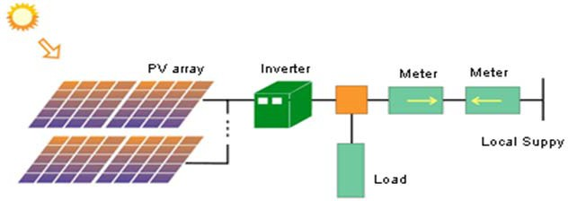

Fig. 1 Typical configuration of grid-connected PV system

The inverter converts the DC power generated by the module to ac and synchronizes it with the grid voltage. It is known the weakest link in the system as it is susceptible to various damaging consequence, particularly lightning strikes. Electronically, the inverter is based on several topologies, as summarized by [3]. The older models come with a low frequency (50/60 Hz) transformer; consequently, it is quite bulky and less efficient. On the other hand, the transformerless inverter is simpler and is relatively lighter [4]. Lately, it is becoming the inverter of choice for many installations. Another inverter topology is based on the high frequency transformer. It is lighter than the low frequency type due to smaller transformer size but it exhibits an efficiency number that is comparable to the transformerless [5]. In terms of connection, the inverter may be connected as

a single string and multi-string in a central-type connection. More recently, the micro-inverter topologies is proposed, in which every module in an individual inverter has attached to it. The main advantage of this approach is in the presence of shading occurs; only that particular module will be affected and not the whole system as with the string type connection. The only downside of this new technology is its relatively expensive price [6].

*A. MPPT*

The inverter is normally equipped with a maximum power point tracking (MPPT) capability. The purpose of MPPT is to match the voltage and current of the inverter with the one delivered by the PV modules so that the maximum power is always extracted from the latter. This is crucial because at any point in time, the maximum power changes due to the variation in irradiance and temperature and. Fig. 2 below shows an example of PV curve which indicate Voc, Isc as well as matching of converter operating point with maximum power point.

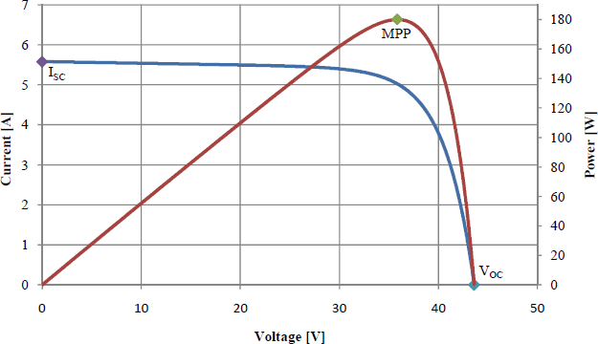

Fig. 2 Example of a PV curve

1. CONCEPT OF PV INVERTER EFFICIENCY The concept of PV inverter efficiency is quite complex. It

is not simply the ratio of the output power to the input power of a black box, as in the case of normal power converter. On the contrary, it comprises of two parts: conversion and MPPT efficiencies. The conversion efficiency is the ratio of the AC energy output to the DC energy input within a defined measuring period, while the MPPT efficiency is the ratio of the energy drawn by the device under test within a defined measuring period to the energy provided theoretically by the PV simulator in the MPP. The real efficiency (which is called the total efficiency) of the PV inverter is the multiplication of these two quantities. Fig 3 depicts the concept of total or overall efficiency. Furthermore, the conversion efficiency can be of two types, namely Peak efficiency and Weighted or Averaged efficiency. The weighted efficiency on the other

hand may come out as European efficiency or even CEC efficiency. Same goes to the MPPT efficiency which also can be of two types; static and dynamic. The different types of PV inverter efficiency are interrelated figuratively as shown in Fig. 4. The details are described in the sections below:

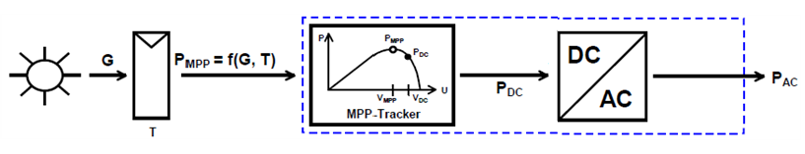

Fig. 3 Illustration of Total Efficiency concept [14]

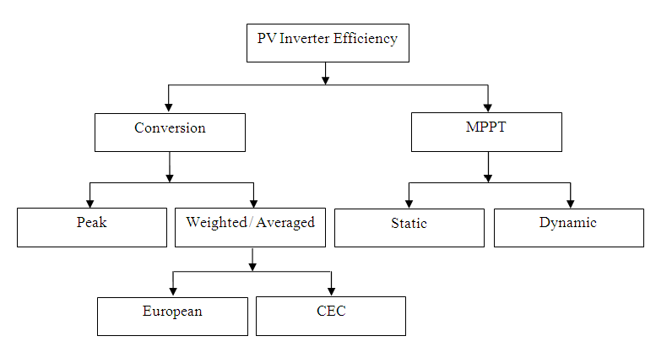

Fig. 4 Classification of PV inverter efficiency

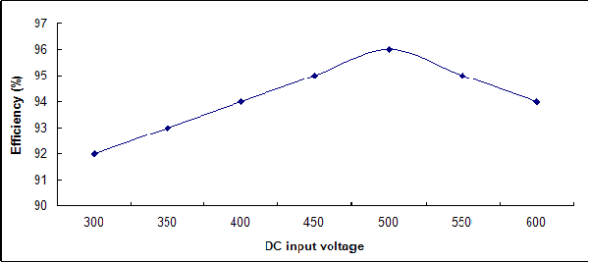

Fig. 5 Peak efficiency [7]

1. *Weighted EU*

Throughout the day solar array output does not remain constant; it is lower in the morning and evening and higher in the afternoon when the sun is shin ng [8]. Thus, an inverter may only operate in its peak efficiency range for a very small part of the day or not at all. From this concern, it is thought that peak efficiency does not reflect the true performance of the PV inverter hence the concept of weighted or averaged conversion efficiency comes into the picture.

PV inverters do not always operate in optimal conditions.

* 1. *Conversion Efficiency*

Therefore weighted or averaged realistic indication of how an

efficiency offers a more inverter might perform

* + 1. *Peak Efficiency*

Peak efficiency or rated output efficiency is probably the most overrated term used to describe PV inverter efficiency

throughout the day [7]. This efficiency also measure inverter performance across the range of its capacity [7]. As introduced by R. Hotopp in [9], European efficiency formula is given by:

whereas it is seldomly or may not be achieved at all. This is

 = *K*

. + *K*

. + *K*

. + *K* .

(2)

true since that it can be found stamped on the casing or

*EURO*

*EU1* 1

*EU2* 2

*EU3* 3

*EU4* 4

written on the data sheet of every available PV inverter in the market. As stated in IEC 61683:1999 it actually refers to the percentage ratio of rated output power of an inverter over input power to inverter at rated output. In equation terms:

+ *KEU5*.5 + *KEU6*.6

where *KEUi* is the weighting factor which is derived from the ratio of irradiance level at particular duration over irradiance

level of the whole duration. The summation of *KEU* will

where

*R* = (*Po* / *Pi*) x *100*

(1)

equals to 1 or 100% [10]. If irradiance curve is given as shown in Fig. 6 below, then:

*η* R is the rated output efficiency (%)

*P*o is the rated output power from inverter (W)

*∑ KEU = KEU1 + KEU2 + KEU3 + KEU4*

Therefore,

*P*i is the input power to inverter at rated output (W)

*∑ K = 1T /T + 2T /T + 3T /T*

*+ 4T /T*

Fig. 5 below shows a typical characteristic of a PV inverter which gives a peak efficiency of 96 % at a dc input

*EU*

Where

1. *WT*
2. *WT*
3. *WT*
4. *WT*

value at around 500 V.

*TWT* = *1T1* + *2T2* + *3T3* + *4T4* (3)

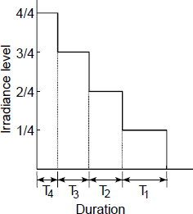

Fig. 6 An example of irradiance duration curve [10]

Therefore the equation will be translated as written below:

* 1. *MPPT Efficiency*

MPPT is nowadays without doubt the fundamental component to maximize the output power of a PV system. This is true since that it always attempts to set the PV system working point as optimum as possible and independent of changing weather conditions in terms of solar irradiance as well as temperature. The MPPT influence on the PV system performance depends both on its static performance and its dynamic performance. Static performance means how closely it can operate to a fixed MPP. Meanwhile dynamic performance means how well can it respond to changes in MPP. To properly evaluate MPPT performance instantaneously synthetic irradiance profiles such as steps and ramps or triangles are used. Hence, a flexible PV array simulator is required [12]

EU = *0.03*.50% + *0.06*.10% + *0.13*.20% +

*0.10*.30% + *0.48*.50% + *0.20*.100%

(4)

1. *Static*

For example 0.03.η5% reads 3% weighting factor multiply with inverter efficiency when operated at 5% of its rated capacity in terms of d.c. Input power. As mentioned above the weighting factors are highly influenced by irradiance data. In this case year 1991 climate data was taken from the city of Trier, which is located at north-western of Germany. At that time irradiance data was measured manually every three hours. The chart below shows that lower irradiation levels are highly emphasized since that most of the nominal operation points were taken from below 50%. Thus European efficiency formula is more suitable to be used in the region with low to medium irradiation level.

*3) Weighted CEC*

As more penetration of Photovoltaic Power System occurs, installation in the southern region with higher irradiation level has also increased. Therefore the California Energy Commission has come out with their own version of PV inverter efficiency formula which is known as CEC efficiency. It is produced according to the irradiance data taken in California for the Sacramento Typical

The static MPPT efficiency describes the ability of the MPPT to find and hold the MPPT under constant environmental conditions such as cell temperature and solar irradiance.

According to [13] for a crystalline type module, the inverter used needs to be tested under three pre-set MPP voltage level which are rated MPP voltage, minimum MPP voltage and maximum MPP voltage which equals to 0.8 of maximum DC voltage. Meanwhile for thin film type, the inverter also needs to be tested at three pre-set MPP voltage level. The only difference is that the maximum MPP voltage this time is equals to 0.7 of maximum DC voltage. These six values need to be at tested at different inverter DC input power level namely at 5%, 10%, 20%, 25%, 30%, 50%, 75% and 100%. Each setting will be measured over a 10 minutes period. To determine the static MPPT efficiency, averages over all the recorded measurements are made. In equation, MPPT efficiency is the ratio of energy drawn by the device under test within a defined measuring period, *TM* to the energy provided theoretically by the PV simulator in the MPP.

Meteorological Year (TMY). The formula is as given below:

MPPT

*J P*

*PMPP*

=

*o*

(7)

CEC = *KCEC1*.1 + *KCEC2*.2 + *KCEC3*.3 +

*KCEC4*.4 + *KCEC5*.5 + *KCEC6*.6

(5) *Jo*

Therefore the equation will be translated as written below:

1. *Dynamic*

CEC = *0.04*.10% + *0.05*.20% + *0.12*.30% +

*0.21*.50% + *0.53*.75% + *0.05*.100%

(6)

The dynamic MPPT efficiency describes the ability of the MPPT in tracking the MPP in case of variable conditions. According to [13] the dynamic MPPT efficiency under

If compared to European efficiency different set of nominal points or efficiency factors were used. Notably, an additional nominal point at 75% irradiance is used that is a major advantage if compared to the European efficiency. The procedure to carry out this efficiency is as specified in [11].

varying irradiance conditions is characterized by using a ramp sequence consisting of irradiance ramp with different gradients and irradiance levels [16]. The aim of this test is to provide a means for fundamental characterization of the

properties and performance of the MPPT function integrated into the inverter under test [13].

Fig. 7 and Fig. 8 show the principle of ramp test sequences for low to medium and medium to high irradiance level. Each test sequence consists of consecutive up and down ramps for every gradient. At high and low level, irradiance is kept constant for a certain dwell time. Before each test, an initial settling time allows the MPPT to stabilize. Only period of ramps in Figure 7 and Figure 8 are taken into considerations for analysis and calculation of the dynamic MPPT efficiencies [13].

Fig. 7 below shows a ramp test sequence for low to medium irradiance which are from 100 W/m2 to 500 W/m2 and ramp gradients ranging from 0.5 W/m2/s up to 100 W/m2/s.

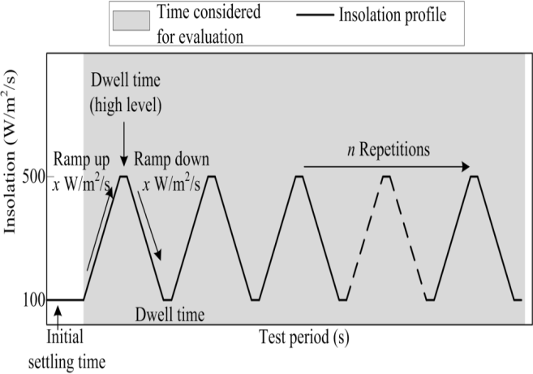

Fig. 7 Ramp test sequence (low-medium insolation) for the characterization

Fig. 9 below describes a test sequence at very low irradiance level which is used to characterize the MPPT performance of the inverter under test during start-up and shut-down periods. This test sequence is however not taken into consideration for dynamic MPPT analysis and calculation.

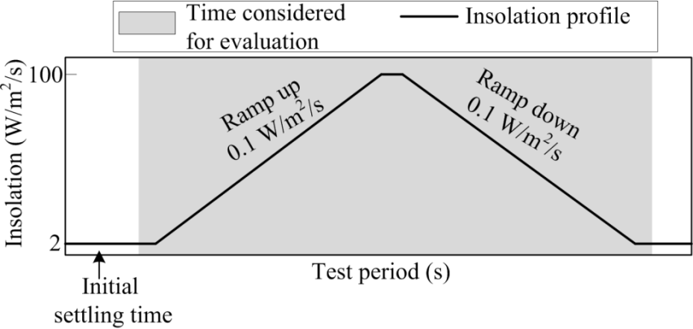

Fig. 9 Additional start-up and shut down test [13]

For each ramp gradient and irradiance level, the dynamic MPPT efficiency is calculated according to the definition as mentioned in Equation (7) above.

* 1. *Total Efficiency*

Total efficiency or overall efficiency combines the calculation of weighted efficiency and the MPPT efficiency. It is used to indicate a more accurate performance of a particular inverter since that all of the available inverter in the market comes together with an embedded MPPT [v]. It is best illustrated by Fig. 3 above.

of the MPPT efficiency under changing insolation conditions [13]

 = 

.  = *PAC . PDC*

(8)

Fig. 8 below on the other hand shows a ramp test sequence

TOTAL

CONV

MPPT

*PDC*

*P PP*

for medium to high irradiance which are from 300 W/m2 to 1000 W/m2 and ramp gradients ranging from 0.5 W/m2/s up to 100 W/m2/s.

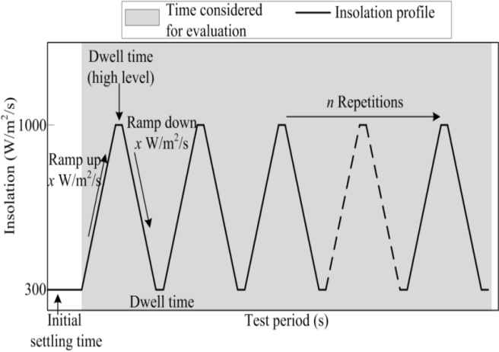

Fig. 8 Ramp test sequence (medium-high insolation) for the characterization of the MPPT efficiency under changing insolation conditions [13]

Equation (8) above shows the formula to evaluate the Overall or Total efficiency. η conv might as well be weighted European efficiency or CEC efficiency [I] and η MPPT refers to either the Static or Dynamic MPPT efficiency. This equation is actually the basis for the world renowned Photon Lab PV inverter efficiency test.

1. CONCLUSION

This paper has discussed the different types of PV inverter efficiency by detailing out the characteristics of each efficiency, analyzing it and relates one to another. The study has shown that all of the existed efficiencies are based on the countries with medium climate. It also shown that PV inverter conversion efficiencies are still based on hourly averaged irradiance data. As South East Asia is being identified as one the most developed region in the world maybe it is the right time to come out with an equation on PV inverter efficiency for Topical Climate with emphasize on the 1 minute interval irradiance for a more accurate reference.

ACKNOWLEDGMENT

This work was funded by the Ministry of Education, Malaysia under the Research University Grant. The grant was managed by the Research Management Centre, Universiti Teknologi Malaysia, with the Vot No. Q.J130000.2509.06H78.

REFERENCES

1. D. Infield, Solar Energy: Photovoltaics, Future Energy: Improved, Sustainable and Clean Options for our Planet (Edited by T.M. Letcher), UK: Elsevier, 2008, pp. 225-238.
2. B. Bletterie, R. Brundlinger and G. Lauss, “On the Characterisation of PV Inverter’s Efficiency – Introduction to the Concept of Achievable Efficiency”, *Progress in Photovoltaics: Research and Applications*, 2011, DOI: 10.1002/pip.1054.
3. A.M. Omar, S. Shaari and S.I. Sulaiman, "Grid-connected Photovoltaic Power Systems Design", Malaysia, Sustainable Energy Development Authority Malaysia (SEDA), February 2012,
4. <http://www.sma.de/en/products/solar-inverters-with-transformer/sunny-> boy-1200-1700-2500-3000.html
5. <http://www.fronius.com/cps/rde/xchg/SID-D426434A-> E753C4B0/fronius_international/hs.xsl/83_384_ENG_HTML.htm
6. <http://enphase.com/explore/enphase-technology/>
7. J. Martin, “Types of Solar Inverter Efficiency” Solar Choice Article on Inverters, August 2011. [Online]. Available: <http://www.solarchoice.net.au/blog/types-of-solar-inverter-efficiency/>
8. A. Shah, "Solar System Efficiency Tutorial on Curve, Types (CEC, European, Average) and Comparison - PV Efficiency Increasing Every Year", Green World Investor, July 2011. [Online]. Available: <http://www.greenworldinvestor.com/2011/07/06/solar-system-inverter> efficiency-tutorial-on-curvetypes-ceceuropeanaverageand-comparision-pv- efficiency-increasing-every-year/
9. R. Hotopp, "Private Photovoltaic-Stromerzeugung-sanlagen im Netzparallelbetrieb", 2. Auflage, RWE Energie AG, Essen, 1991.
10. “IEC 61683: Photovoltaic systems – Power conditioners – Procedure for measuring efficiency (German version EN 61683). 1999”.
11. W. Bower, C. Whitaker, W. Erdman, M. Behnke and M. Fitzgerald, “Performance Test Protocol for Evaluating Inverters Used in Grid-Connected Photovoltaic Systems”, Sandia National Laboratory, Tech. Rep., October 2004.Availab[le:h](http://www.bewengineering.com/docs/InvetrTestProto_0410)ttp[://www.bewengineering.com/docs/InvetrTestProto_0410](http://www.bewengineering.com/docs/InvetrTestProto_0410) 14.pdf
12. M. Valentini, A. Raducu, D. Sera and R. Teodorescu, “PV Inverter Test Setup for European Efficiency, Static and Dynamic MPPT Efficiency Evaluation”, *11th International Conference on Optimization of Electrical and Electronic Equipment, 2008, OPTIM 2008*, pp. 433-438, 22-24 May 2008.
13. R. Brundlinger, N. Henze, H. Haberlin, B. Burger, A. Bergmann and F. Baumgartner, “prEN 50530 – The New European Standard for Performance Characterisation of PV Inverters”, *Proceedings of 24th. European Photovoltaic Solar Energy Conference*, Hamburg, Germany, September 2009, pp. 3105 – 3109, DOI: 10.4229/24thEUPVSEC2009-4EP.1.2

October 2001.

1. H. Haberlin, L. Borgna, M. Kaempfer and U. Zwahlen, "Total Efficiency ηTOT - A New Quantity for Better Characterization of Grid- connected PV Inverters", 20th European Photovoltaic Solar Energy Conference, Barcelona, Spain, June 2005, pp. 1-4.
2. Z. Salam, J. Ahmed and B.S. Merugu, “The application of soft computing methods for MPPT of PV system: A technological and status review”, Applied Energy 107 (2013) 135–148.
3. K. Ishaque, Z. Salam and G. Lauss, “The performance of perturb and observe and incremental conductance maximum power point tracking method under dynamic weather conditions”, Applied Energy 119 (2014) 228–236.